Supplementary Project

design & implementation

Sheik Mohammed Kashim Miah (14013095)

2018

Contents

**Original Design** 2

**Homepage/MainPage** 2

**CV Upload Page** 3

**Feedback Page** 3

**Implementation** 4

**Main page/homepage** 4

**CV Uploading Page** 5

**Feedback Page** 6

**Implementation codes** 7

**Main page:** 7

**CV Upload Page:** 9

**Feedback Page:** 14

# **Original Design**

Within this documentation I will simply provide very brief description of design to implementation along with the codes to construct the final product.

## **Homepage/MainPage**

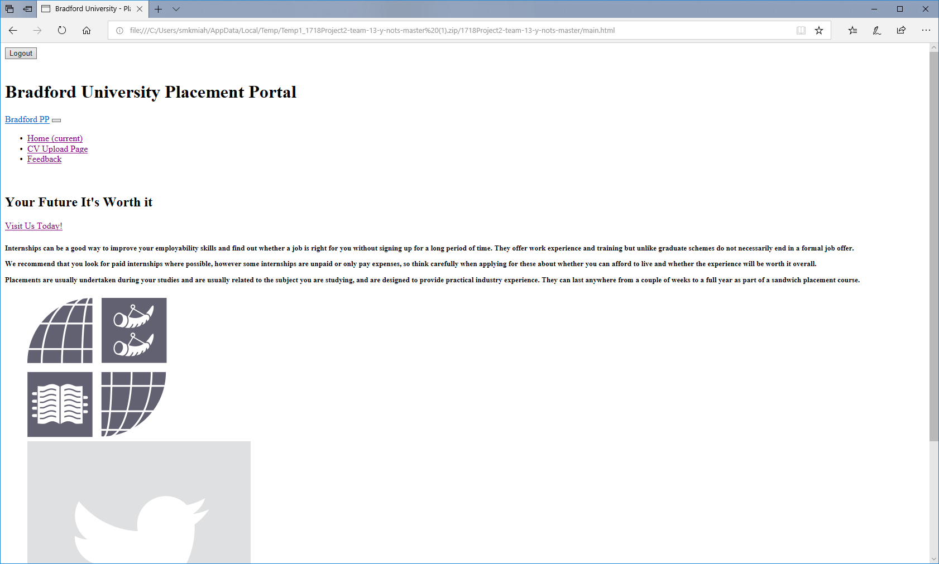As you can see the original Design was very basic and lack of attractions in the background. The main/homepage had simple jpeg images and very basic. None of navigations to other webpages worked. The design below is the initial visual interface for the end user.

## **CV Upload Page**

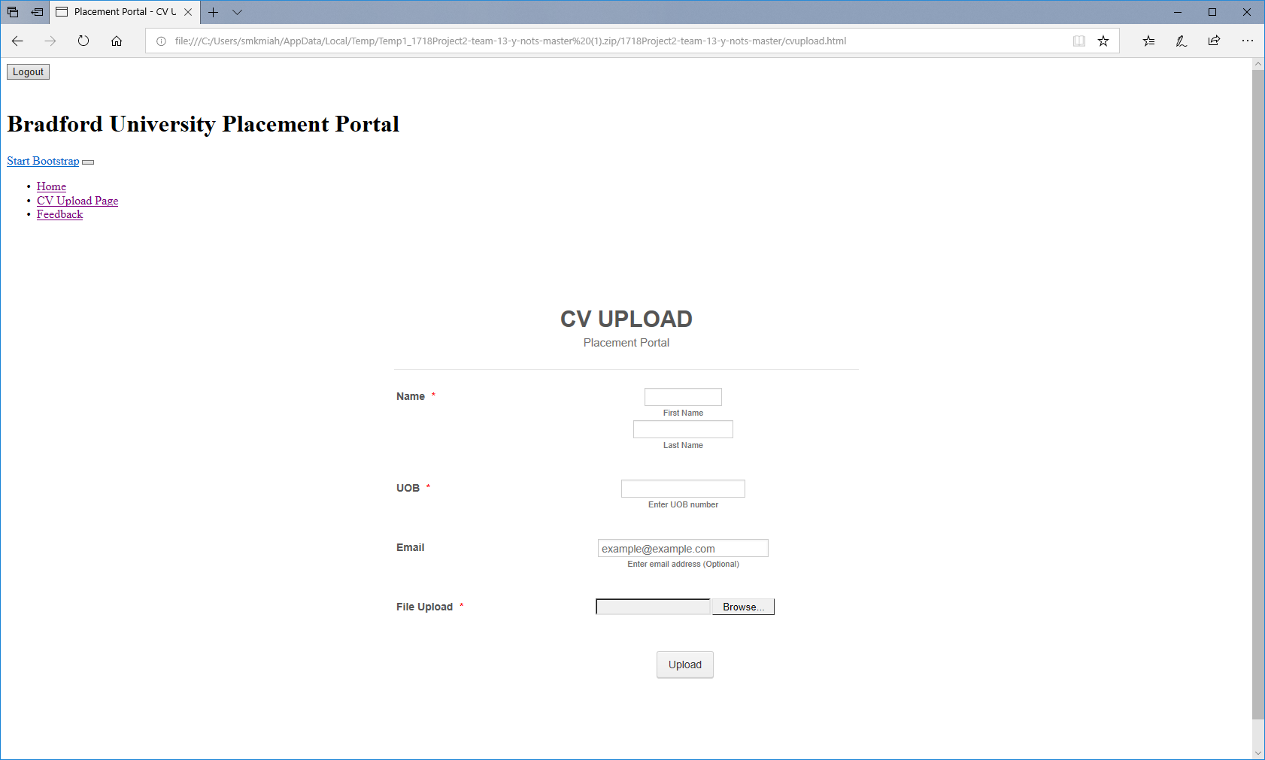The CV upload page had no background and was simply basic as it had no soul or empathy towards the website. The navigation links did not perfom up to the purpose. The design and structre of the webpage was very plain as you can tell.

## **Feedback Page**

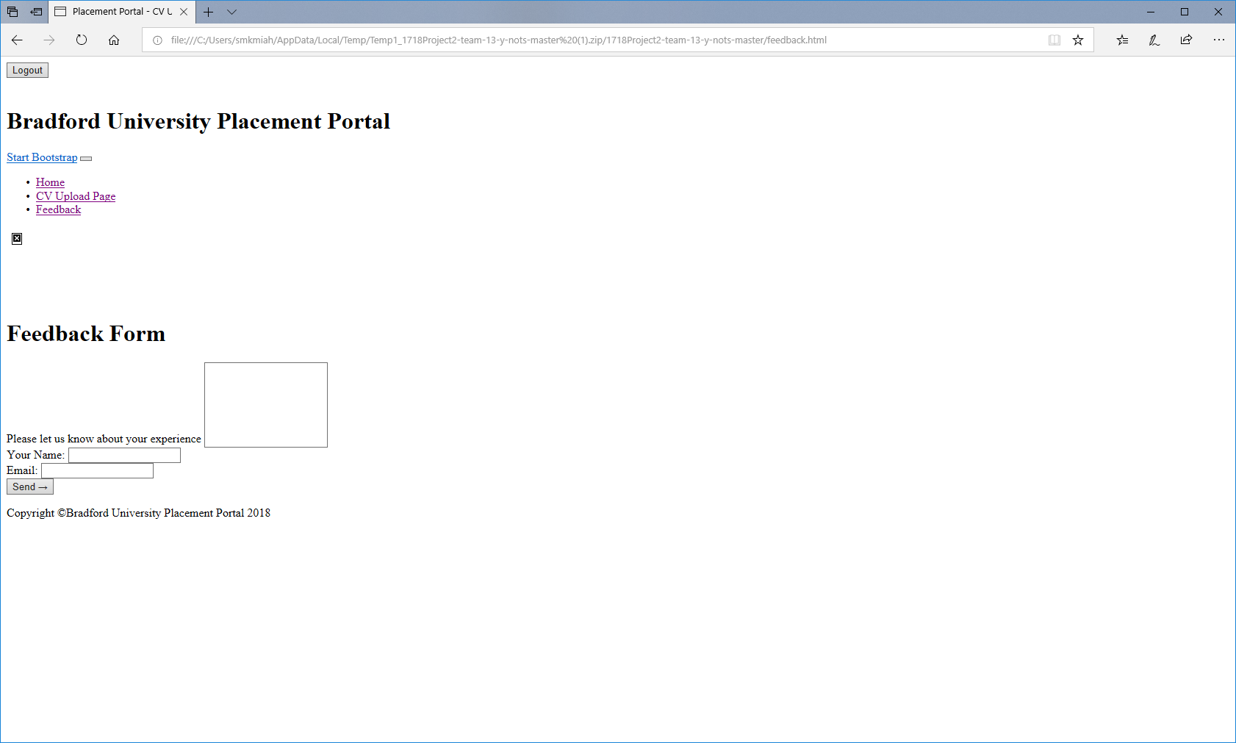The Feedback page original design has no background and very much limited detail to attention. The interactive boxes were not aligned properly.

# **Implementation**

## **Main page/homepage**

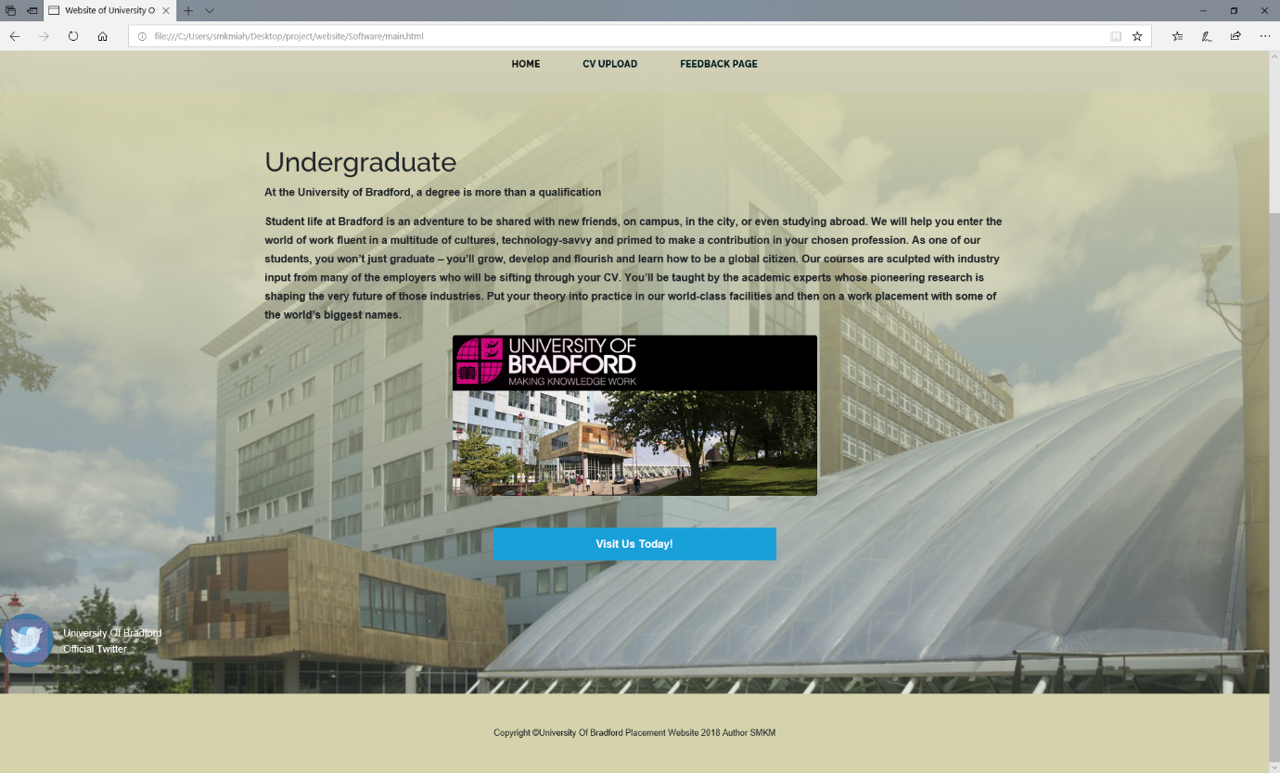Below as you can tell I have implemented the main page of the student’s placement website. This webpage has been designed accordingly to the original website design. However I have implemented few certain twitches that makes this webpage stand out. The centred image and information, the highlighted navigation bar and links. The information provided to aid the user. I have also linked in the university of Bradford engineering and informatics faculty website. The twitter/Facebook link to the university page as rollover.

## **CV Uploading Page**

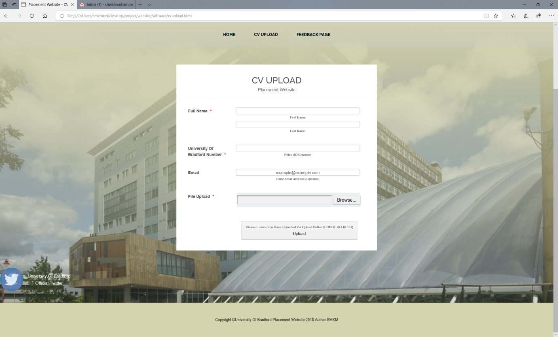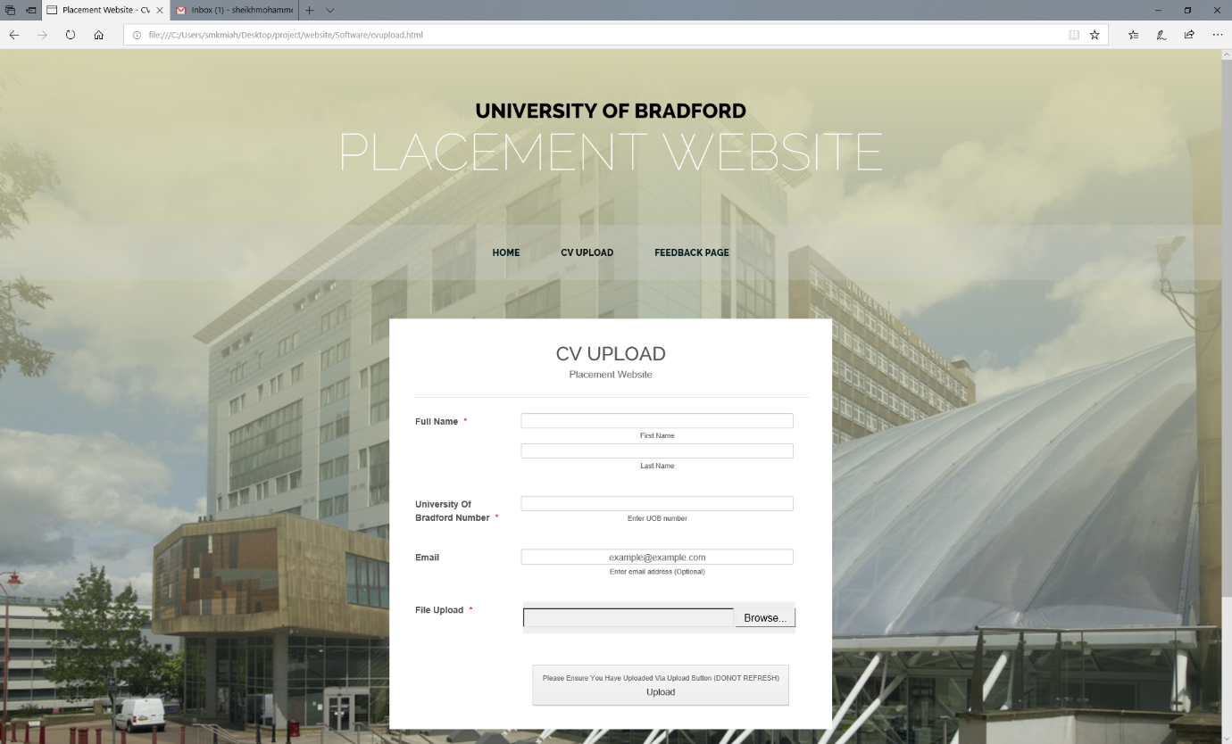The CV uploading page has been implemented with subtle background which has transparency affect and I have centred the interaction section as it will able to make the end user understand. I have changed the format of the form from the original design. I have equally sectioned the form and links below.

## **Feedback Page**

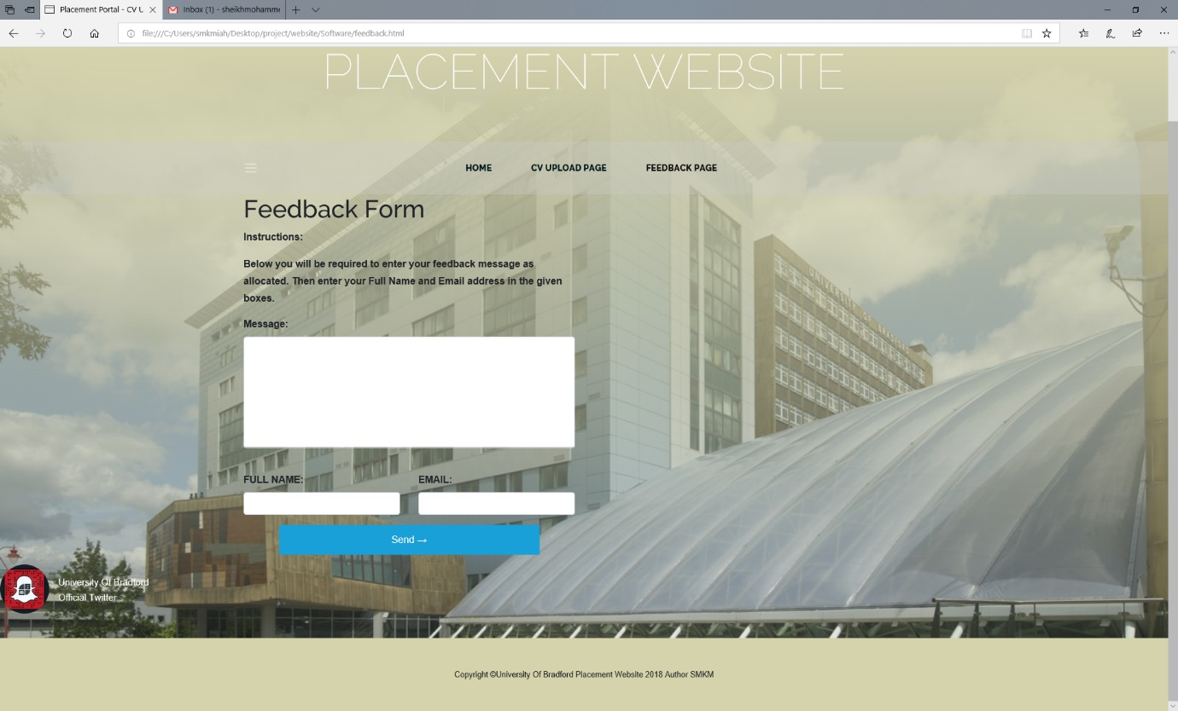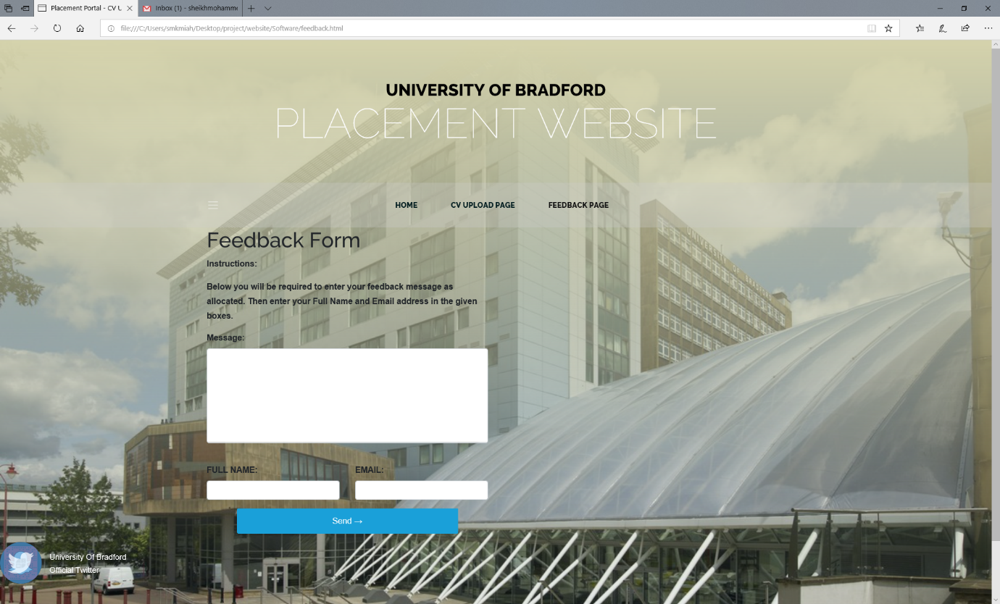The Feedback page obtains the elegant format from the last two webpages and continues the same elegant transparency background. The interactions section was all disorganised and was not placed in correct positioning. As you can tell I used the html codes to <br> </br> the sections to resolve the disoriented interaction boxes. I have also added few subtle details as you can visual tell. In addition the feedback form initially did not obtain certain instructions or information in order to aid the end user. Within the coding of html I simply added an instructions box notifying the end user how to use the simple but elegant feedback form.

# **Implementation codes**

## **Main page:**

<!DOCTYPE html>

<html lang="en">

<head>

<meta charset="utf-8">

<meta name="viewport" content="width=device-width, initial-scale=1, shrink-to-fit=no">

<meta name="description" content="">

<meta name="author" content="">

<title>Website of University Of Bradford</title>

<!-- Bootstrap core CSS -->

<link href="vendor/bootstrap/css/bootstrap.min.css" rel="stylesheet">

<!-- Custom fonts for this template -->

<link href="https://fonts.googleapis.com/css?family=Raleway:100,100i,200,200i,300,300i,400,400i,500,500i,600,600i,700,700i,800,800i,900,900i" rel="stylesheet">

<link href="https://fonts.googleapis.com/css?family=Lora:400,400i,700,700i" rel="stylesheet">

<!-- Custom styles for this template -->

<link href="css/business-casual.css" rel="stylesheet">

</head>

<body>

<h1 class="site-heading text-center text-white d-none d-lg-block">

<span class="site-heading-upper text-primary mb-3">University Of Bradford</span>

<span class="site-heading-lower">Placement Website</span>

</h1>

<!-- Navigation -->

<nav class="navbar navbar-expand-lg navbar-dark py-lg-4" id="mainNav">

<div class="container">

<a class="navbar-brand text-uppercase text-expanded font-weight-bold d-lg-none" href="#">Bradford PP</a>

<button class="navbar-toggler" type="button" data-toggle="collapse" data-target="#navbarResponsive" aria-controls="navbarResponsive" aria-expanded="false" aria-label="Toggle navigation">

<span class="navbar-toggler-icon"></span>

</button>

<div class="collapse navbar-collapse" id="navbarResponsive">

<ul class="navbar-nav mx-auto">

<li class="nav-item active px-lg-4">

<a class="nav-link text-uppercase text-expanded" href="main.html">Home

<span class="sr-only">(current)</span>

</a>

</li>

<li class="nav-item px-lg-4">

<a class="nav-link text-uppercase text-expanded" href="cvupload.html">CV Upload </a>

</li>

<li class="nav-item px-lg-4">

<a class="nav-link text-uppercase text-expanded" href="feedback.html">Feedback Page</a>

</li>

</ul>

</div>

</div>

</nav>

<section class="page-section">

<div class="container">

<b>

<h1>Undergraduate</h1>

<p>At the University of Bradford, a degree is more than a qualification</p>

<p>Student life at Bradford is an adventure to be shared with new friends, on campus, in the city, or even studying abroad.

We will help you enter the world of work fluent in a multitude of cultures, technology-savvy and primed to make a contribution in your chosen profession.

As one of our students, you won’t just graduate – you’ll grow, develop and flourish and learn how to be a global citizen.

Our courses are sculpted with industry input from many of the employers who will be sifting through your CV.

You’ll be taught by the academic experts whose pioneering research is shaping the very future of those industries.

Put your theory into practice in our world-class facilities and then on a work placement with some of the world’s biggest names.

</p>

</b>

<center>

<img class="intro-img img-fluid mb-3 mb-lg-0 rounded" src="img/WebsiteImageBradford.png" alt="">

</center>

</br>

</br>

<div class="intro-button mx-auto">

<a class="btn btn-primary btn-xl" href="https://www.bradford.ac.uk/ei/">Visit Us Today!</a>

</div>

</section>

</div>

</section>

<!-- twitter -->

<figure class="fir-image-figure">

<a class="fir-imageover" rel="noopener" target="_blank" href="https://twitter.com/UniofBradford">

<img class="fir-author-image fir-clickcircle" src="https://pbs.twimg.com/profile_images/880023407605280769/NgvZtaF5_400x400.jpg" alt="David East - Author">

<div class="fir-imageover-color"></div>

<img class="fir-imageover-image fir-clickcircle" src="https://fir-rollup.firebaseapp.com/twitter-logo.png" />

</a>

<figcaption>

<div class="fig-author-figure-title">University Of Bradford</div>

<div class="fig-author-figure-title">Official Twitter</div>

</figcaption>

</figure>

<footer class="footer text-faded text-center py-5">

<div class="container">

<p class="m-0 small">Copyright &copy;University Of Bradford Placement Website 2018 Author SMKM</p>

</div>

</footer>

<!-- Bootstrap core JavaScript -->

<script src="vendor/jquery/jquery.min.js"></script>

<script src="vendor/bootstrap/js/bootstrap.bundle.min.js"></script>

</body>

</html>

## **CV Upload Page:**

<!DOCTYPE html>

<html lang="en">

<html>

<head>

<meta charset="utf-8">

<meta name="viewport" content="width=device-width, initial-scale=1, shrink-to-fit=no">

<meta name="description" content="">

<meta name="author" content="">

<title>Placement Website - CV Upload</title>

<!-- Bootstrap core CSS -->

<link href="vendor/bootstrap/css/bootstrap.min.css" rel="stylesheet">

<!-- Custom fonts for this template -->

<link href="https://fonts.googleapis.com/css?family=Raleway:100,100i,200,200i,300,300i,400,400i,500,500i,600,600i,700,700i,800,800i,900,900i" rel="stylesheet">

<link href="https://fonts.googleapis.com/css?family=Lora:400,400i,700,700i" rel="stylesheet">

<!-- Custom styles for this template -->

<link href="css/business-casual.css" rel="stylesheet">

</head>

<body>

<h1 class="site-heading text-center text-white d-none d-lg-block">

<span class="site-heading-upper text-primary mb-3">University Of Bradford</span>

<span class="site-heading-lower">Placement Website</span>

</h1>

<!-- Navigation -->

<nav class="navbar navbar-expand-lg navbar-dark py-lg-4" id="mainNav">

<div class="container">

<a class="navbar-brand text-uppercase text-expanded font-weight-bold d-lg-none" href="#">Start Bootstrap</a>

<button class="navbar-toggler" type="button" data-toggle="collapse" data-target="#navbarResponsive" aria-controls="navbarResponsive" aria-expanded="false" aria-label="Toggle navigation">

<span class="navbar-toggler-icon"></span>

</button>

<div class="collapse navbar-collapse" id="navbarResponsive">

<ul class="navbar-nav mx-auto">

<li class="nav-item px-lg-4">

<a class="nav-link text-uppercase text-expanded" href="main.html">Home

</a>

</li>

<li class="nav-item active px-lg-4">

<a class="nav-link text-uppercase text-expanded" href="cvupload.html">CV Upload </a>

</li>

<li class="nav-item px-lg-4">

<a class="nav-link text-uppercase text-expanded" href="feedback.html">Feedback Page</a>

</li>

</ul>

</div>

</div>

</nav>

<!-- CV Upload-->

<title>CV UPLOAD</title>

<link href="https://cdn.jotfor.ms/static/formCss.css?3.3.5623" rel="stylesheet" type="text/css" />

<link type="text/css" rel="stylesheet" href="https://cdn.jotfor.ms/css/styles/nova.css?3.3.5623" />

<link type="text/css" media="print" rel="stylesheet" href="https://cdn.jotfor.ms/css/printForm.css?3.3.5623" />

<link type="text/css" rel="stylesheet" href="https://cdn.jotfor.ms/themes/CSS/566a91c2977cdfcd478b4567.css?" />

<script src="https://cdn.jotfor.ms/js/vendor/imageinfo.js?v=3.3.5623" type="text/javascript"></script>

<script src="https://cdn.jotfor.ms/static/prototype.forms.js" type="text/javascript"></script>

<script src="https://cdn.jotfor.ms/static/jotform.forms.js?3.3.5623" type="text/javascript"></script>

<script type="text/javascript">

JotForm.init(function() {

setTimeout(function() {

$('input_5').hint('example@example.com');

}, 20);

JotForm.alterTexts(undefined);

JotForm.clearFieldOnHide = "disable";

JotForm.submitError = "jumpToFirstError";

/*INIT-END*/

});

JotForm.prepareCalculationsOnTheFly([null, {

"name": "heading",

"qid": "1",

"text": "CV UPLOAD",

"type": "control_head"

}, {

"name": "submit2",

"qid": "2",

"text": "Upload",

"type": "control_button"

}, {

"description": "",

"name": "name",

"qid": "3",

"text": "Name",

"type": "control_fullname"

}, {

"description": "",

"name": "typeA",

"qid": "4",

"subLabel": "Enter UOB number ",

"text": "UOB",

"type": "control_textbox"

}, {

"description": "",

"name": "email",

"qid": "5",

"subLabel": "Enter email address (Optional)",

"text": "Email",

"type": "control_email"

}, {

"description": "",

"name": "input6",

"qid": "6",

"subLabel": "",

"text": "File Upload",

"type": "control_fileupload"

}]);

setTimeout(function() {

JotForm.paymentExtrasOnTheFly([null, {

"name": "heading",

"qid": "1",

"text": "CV UPLOAD",

"type": "control_head"

}, {

"name": "submit2",

"qid": "2",

"text": "Upload",

"type": "control_button"

}, {

"description": "",

"name": "name",

"qid": "3",

"text": "Name",

"type": "control_fullname"

}, {

"description": "",

"name": "typeA",

"qid": "4",

"subLabel": "Enter UOB number ",

"text": "UOB",

"type": "control_textbox"

}, {

"description": "",

"name": "email",

"qid": "5",

"subLabel": "Enter email address (Optional)",

"text": "Email",

"type": "control_email"

}, {

"description": "",

"name": "input6",

"qid": "6",

"subLabel": "",

"text": "File Upload",

"type": "control_fileupload"

}]);

}, 20);

</script>

<center>

<body>

<form class="jotform-form" action="https://submit.jotformeu.com/submit/81015127482349/" method="post" enctype="multipart/form-data" name="form_81015127482349" id="81015127482349" accept-charset="utf-8">

<input type="hidden" name="formID" value="81015127482349" />

<div class="form-all">

<ul class="form-section page-section">

<li id="cid_1" class="form-input-wide" data-type="control_head">

<div class="form-header-group ">

<div class="header-text httac htvam">

<h1 id="header_1" class="form-header" data-component="header">

CV UPLOAD

</h1>

<div id="subHeader_1" class="form-subHeader">

Placement Website

</div>

</div>

</div>

</li>

<li class="form-line jf-required" data-type="control_fullname" id="id_3">

<label class="form-label form-label-left form-label-auto" id="label_3" for="first_3">

Full Name

<span class="form-required">

*

</span>

</label>

<div id="cid_3" class="form-input jf-required">

<div data-wrapper-react="true">

<span class="form-sub-label-container" style="vertical-align:top">

<input type="text" id="first_3" name="q3_name[first]" class="form-textbox validate[required]" size="10" value="" data-component="first" required="" />

<label class="form-sub-label" for="first_3" id="sublabel_first" style="min-height:13px"> First Name </label>

</span>

<center> <span class="form-sub-label-container" style="vertical-align:top">

<input type="text" id="last_3" name="q3_name[last]" class="form-textbox validate[required]" size="15" value="" data-component="last" required="" />

<label class="form-sub-label" for="last_3" id="sublabel_last" style="min-height:13px"> Last Name </label>

</span></center>

</div>

</div>

</li>

<li class="form-line jf-required" data-type="control_textbox" id="id_4">

<label class="form-label form-label-left form-label-auto" id="label_4" for="input_4">

University Of Bradford Number

<span class="form-required">

*

</span>

</label>

<div id="cid_4" class="form-input jf-required">

<span class="form-sub-label-container" style="vertical-align:top">

<input type="text" id="input_4" name="q4_typeA" data-type="input-textbox" class="form-textbox validate[required, Fill Mask]" size="20" value="" maxLength="8" data-component="textbox" required="" />

<label class="form-sub-label" for="input_4" style="min-height:13px"> Enter UOB number </label>

</span>

</div>

</li>

<li class="form-line" data-type="control_email" id="id_5">

<label class="form-label form-label-left form-label-auto" id="label_5" for="input_5"> Email </label>

<div id="cid_5" class="form-input">

<span class="form-sub-label-container" style="vertical-align:top">

<input type="email" id="input_5" name="q5_email" class="form-textbox validate[Email]" size="30" value="" placeholder="example@example.com" data-component="email" />

<label class="form-sub-label" for="input_5" style="min-height:13px"> Enter email address (Optional) </label>

</span>

</div>

</li>

<li class="form-line jf-required" data-type="control_fileupload" id="id_6">

<label class="form-label form-label-left form-label-auto" id="label_6" for="input_6">

File Upload

<span class="form-required">

*

</span>

</label>

<div id="cid_6" class="form-input jf-required">

<input type="file" id="input_6" name="q6_input6" class="form-upload validate[required]" data-imagevalidate="yes" data-file-accept="pdf, doc, docx, xls, xlsx, csv, txt, rtf, zip, jpg, jpeg, png" data-file-maxsize="10854" data-file-minsize="0" data-file-limit="" data-component="fileupload" required="" />

</div>

</li>

<li class="form-line" data-type="control_button" id="id_2">

<div id="cid_2" class="form-input-wide">

<div style="margin-left:156px" class="form-buttons-wrapper">

<button id="input_2" type="submit" class="form-submit-button" data-component="button">

<label class="form-sub-label" for="input_5" style="min-height:13px"> Please Ensure You Have Uploaded Via Upload Button (DONOT REFRESH) </label>

Upload

</button>

</div>

</div>

</li>

</ul>

</div>

</form>

</body>

<script type="text/javascript">

JotForm.ownerView = true;

</script>

<script type="text/javascript">

JotForm.forwardToEu = true;

</script>

<script type="text/javascript">

JotForm.ownerView = true;

</script>

<script type="text/javascript">

JotForm.forwardToEu = true;

</script>

<!-- twitter -->

<figure class="fir-image-figure">

<a class="fir-imageover" rel="noopener" target="_blank" href="https://twitter.com/UniofBradford">

<img class="fir-author-image fir-clickcircle" src="https://pbs.twimg.com/profile_images/880023407605280769/NgvZtaF5_400x400.jpg" alt="David East - Author">

<div class="fir-imageover-color"></div>

<img class="fir-imageover-image fir-clickcircle" src="https://fir-rollup.firebaseapp.com/twitter-logo.png" />

</a>

<figcaption>

<div class="fig-author-figure-title">University Of Bradford</div>

<div class="fig-author-figure-title">Official Twitter</div>

</figcaption>

</figure>

<footer class="footer text-faded text-center py-5">

<div class="container">

<b>

<p class="m-0 small">Copyright &copy;University Of Bradford Placement Website 2018 Author SMKM</p>

</b>

</div>

</footer>

<!-- Bootstrap core JavaScript -->

<script src="vendor/jquery/jquery.min.js"></script>

<script src="vendor/bootstrap/js/bootstrap.bundle.min.js"></script>

</center>

</body>

</html>

## **Feedback Page:**

<!DOCTYPE html>

<html lang="en">

<head>

<meta charset="utf-8">

<meta name="viewport" content="width=device-width, initial-scale=1, shrink-to-fit=no">

<meta name="description" content="">

<meta name="author" content="">

<title>Placement Portal - CV Upload</title>

<!-- Bootstrap core CSS -->

<link href="vendor/bootstrap/css/bootstrap.min.css" rel="stylesheet">

<!-- Custom fonts for this template -->

<link href="https://fonts.googleapis.com/css?family=Raleway:100,100i,200,200i,300,300i,400,400i,500,500i,600,600i,700,700i,800,800i,900,900i" rel="stylesheet">

<link href="https://fonts.googleapis.com/css?family=Lora:400,400i,700,700i" rel="stylesheet">

<!-- Custom styles for this template -->

<link href="css/business-casual.css" rel="stylesheet">

</head>

<body>

<h1 class="site-heading text-center text-white d-none d-lg-block">

<center>

<span class="site-heading-upper text-primary mb-3">University Of Bradford</span>

<center>

<span class="site-heading-lower">Placement Website</span>

</h1>

<!-- Navigation -->

<nav class="navbar navbar-expand-lg navbar-dark py-lg-4" id="mainNav">

<div class="container">

<center>

</center>

<span class="navbar-toggler-icon"></span>

</button>

<div class="collapse navbar-collapse" id="navbarResponsive">

<ul class="navbar-nav mx-auto">

<li class="nav-item px-lg-4">

<a class="nav-link text-uppercase text-expanded" href="main.html">HOME

</a>

</li>

<li class="nav-item px-lg-4">

<a class="nav-link text-uppercase text-expanded" href="cvupload.html">CV Upload Page</a>

</li>

<li class="nav-item active px-lg-4">

<a class="nav-link text-uppercase text-expanded" href="feedback.html">Feedback Page</a>

</li>

</ul>

</div>

</div>

</nav>

<!-- Feedback Form -->

<div class="container">

<div class="row">

<div class="col-md-6 col-md-offset-3" id="form_container">

<b>

<h1>Feedback Form</h1>

<p>Instructions:</p>

<p>Below you will be required to enter your feedback message as allocated. Then enter your Full Name and Email address in the given boxes.</p>

</b>

<form role="form" method="post" id="reused_form">

<div class="row">

<div class="col-sm-12 form-group">

<b>

<label for="message"> Message:</label>

</br>

<textarea class="form-control" type="textarea" name="message" id="message" maxlength="6000000" rows="7"></textarea>

</br>

</b>

</div>

</br>

</div>

<div class="row">

<div class="col-sm-6 form-group">

<b>

<label for="name"> FULL NAME:</label>

</br>

<input type="text" class="form-control" id="name" name="name" required>

</b>

</div>

<div class="col-sm-6 form-group">

<b>

<label for="email"> EMAIL:</label>

</br>

<input type="email" class="form-control" id="email" name="email" required>

</b>

</div>

</br>

</div>

<div class="row">

<div class="col-sm-12 form-group">

<button type="submit" class="btn btn-lg btn-default pull-right" >Send &rarr;</button>

</div>

</div>

</form>

<div id="success_message" style="width:100%; height:100%; display:none; "> <h3>Posted your message successfully!</h3> </div>

<div id="error_message" style="width:100%; height:100%; display:none; "> <h3>Error</h3> Sorry there was an error sending your form. </div>

</div>

</div>

</div>

<!-- twitter -->

<figure class="fir-image-figure">

<a class="fir-imageover" rel="noopener" target="_blank" href="https://twitter.com/UniofBradford">

<img class="fir-author-image fir-clickcircle" src="https://pbs.twimg.com/profile_images/880023407605280769/NgvZtaF5_400x400.jpg" alt="David East - Author">

<div class="fir-imageover-color"></div>

<img class="fir-imageover-image fir-clickcircle" src="https://fir-rollup.firebaseapp.com/twitter-logo.png" />

</a>

<figcaption>

<div class="fig-author-figure-title">University Of Bradford</div>

<div class="fig-author-figure-title">Official Twitter</div>

</figcaption>

</figure>

<footer class="footer text-faded text-center py-5">

<div class="container">

<center>

<b>

<p class="m-0 small">Copyright &copy;University Of Bradford Placement Website 2018 Author SMKM</p>

</b>

</center>

</div>

</footer>

<!-- Bootstrap core JavaScript -->

<script src="vendor/jquery/jquery.min.js"></script>

<script src="vendor/bootstrap/js/bootstrap.bundle.min.js"></script>

<script src="form.js"></script>

</body>

</html>